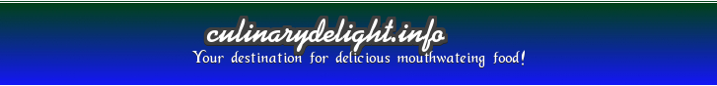

**Administrator Guide**

*Team Perera et.al*



Prepared on: December 6, 2013

## Home Page

Beginning at the **home** page, click **log in** tag at the right top of the page:

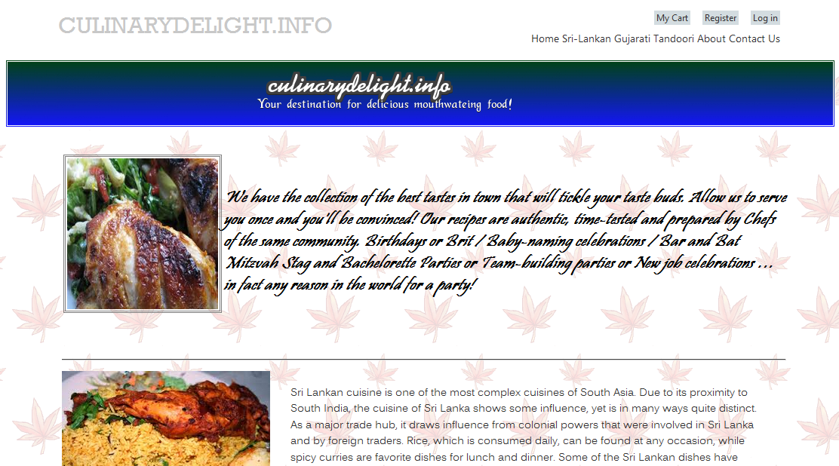

## In the login page

Enter **admin** as the user name and **!123456** as the password. Click **Log in** button:

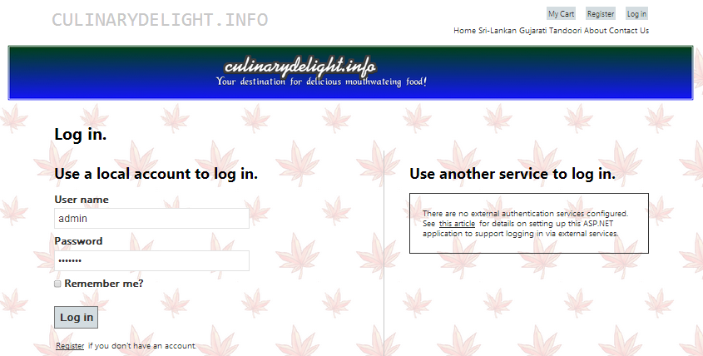

You have logged in as an administrator. Click the **Product Admin** link:

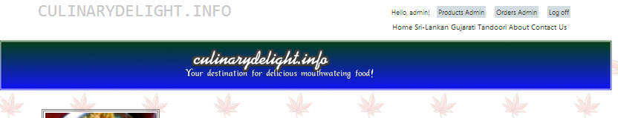

## In the product administration page

You will see a list of product items.

Click the **Delete** link relate to each item. You can delete one item from the system.

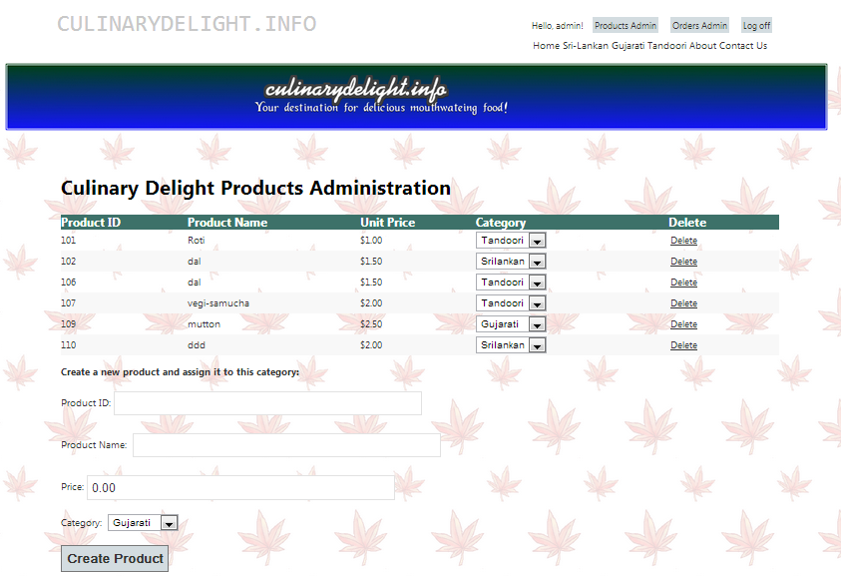

If you enter a new product ID, product name, and price; select a category for new item, then click **Create Product** button; you will create a new item for the system to sell and it will post in the product list.

## In the orders administration page

Click **Orders Admin** link at the right top of page to get into the orders administration page:

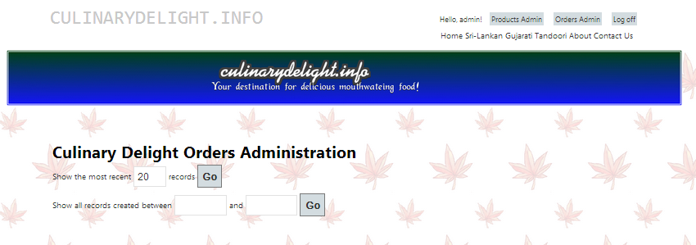

There are to options for you to go:

1. Enter a new number or use the default number in the show recent records row, and click **Go** button to show the recent order records.
2. Enter two different days to show order records between these two days, and then click **Go** button.

System will list the orders in your option’s click:

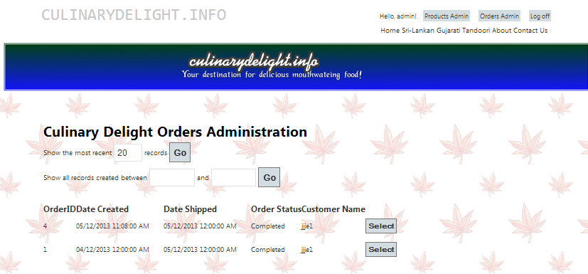

Beside each order, there is Select button. Click **Select** button. You will go to the order details page for the selected order.

## In the order details administration page

You can see the order’s total amount; created date; shipping date; order status; order comments; customer’s user name and items belong to this order.

Click **Edit** button to make the order editable.

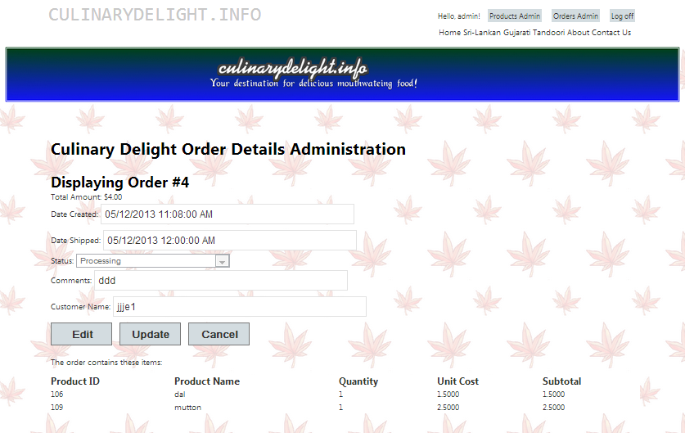

You can enter shipping date, charge order status and add comments for the order.

Click **Update** button to save the change you make to the order.

Click **Cancel** button to not save any change you have made.

After you finish all your work, click **Log off** tag at the right top of the page to logout the administrator account.